Tableau to Power BI Conversion
~ Tanur and Surag M

Objectives
- Automate the conversion of Tableau calculations into DAX expressions
- Enable scalable migration from Tableau to Power BI
- Reduce dependency on manual interpretation and domain-specific expertise.
- Deliver a reusable, extensible solution for future analytics modernization.
Summary
- Problem: Manual Tableau-to-DAX conversion is time-consuming, error-prone, and inconsistent.
- Solution: a Python-based script that automates conversion across multiple Excel sheets and files.
- Impact: improved efficiency, reduced manual effort, and scalable migration support.
Solution Architecture
Components:
Component | Description
Input Folder | Contains Metadata extracted file which includes tableau calculations across multiple sheets.
Mapping Engine | Script with 70+ conversion rules for Tableau-to-DAX translation.
Parser | Reads each sheet, extracts expressions, apply mappings.
Output Folder | Stores converted Excel files with DAX expressions in adjacent columns.

Technologies Used:
- Python (openpyxl, pandas, regex)
- Excel (for input/output)
- Rule-based mapping logic
Workflow

Core Functionality of the code
The script is written in Python using pandas, openpyxl, and regex. It performs the following:
- Regex-Based Transformation: Converts Tableau functions like ZN, IFNULL, DATEPART, RANK, LOOKUP, and WINDOW_PERCENTILE into their DAX equivalents using pattern matching.
- LOD Expression Handling: Parses {FIXED}, {INCLUDE}, and {EXCLUDE} expressions and rewrites them using CALCULATE, ALLEXCEPT, REMOVEFILTERS, and KEEPFILTERS.
- Conditional Logic Conversion: Converts nested IF and CASE statements into SWITCH (TRUE (), ...) format for cleaner DAX logic.
- Sheet-Wise Processing: Processes each sheet independently, ensuring multi-sheet Excel files are fully supported.
Output Structuring: Writes the original Tableau logic and the corresponding DAX expression side-by-side for easy validation.
Sample Conversion Table
Tableau Expression | DAX Equivalent
ZN([Profit]) | IF(ISBLANK(Profit]), 0, [Profit])
{FIXED [Region]: SUM([Sales])}
  CALCULATE(SUM([Sales]), ALLEXCEPT ('Table', 'Table'[Region]))
IF [Sales] > 100 THEN "High" | SWITCH (TRUE (), [Sales] > 100, "High")
REPLACE ([Product Name], "Old", "New") | SUBSTITUTE ([Product Name], "Old", "New")
Time and effort saving analysis
Task | Manual Effort (per file) | Automated Effort (per file) | Time Saved
Open Excel & locate sheets | 2 minutes | 0 minutes | ~2 minutes
Identify Tableau expressions and convert them to DAX | 40–50 minutes | 1-2 minutes | ~39-48 minutes
Validate the converted queries & save output | 5 minutes | 15-20 minutes | 10-15 minutes  (-ve saving)
Total per file | 47–57 minutes | 16-22 minutes | ~31-35 minutes
*Reviewing converted outputs takes less time in the manual path since the logic is applied directly by the user, leaving a minimal need for validation. In contrast, automated conversions often require thorough review to ensure accuracy, as some outputs may need correction or refinement.

Estimated Time Reduction: ~65-70% per file. Scalability Impact for 20 Dashboards:
- Manual effort: ~ 16-19 hours
- Automated effort: ~ 5-7 hours
- Net savings: ~9-14 hours
- This efficiency gain not only accelerates migration timelines but also frees up analysts to focus on higher-value tasks like validation, optimization, and stakeholder engagement.

A column “Dax Expression” is created in the sheet where the “Calculation” column is present and the corresponding Dax Equivalent expressions are added beside the Tableau Calculations in the excel sheet. Then all these converted Excel Sheets, will be saved in an Output Folder with the same name as the Original sheet name.

Challenges
- Complex Tableau logic may require manual review.
Example: Nested LOD
{ EXCLUDE [Country]:MAX (INCLUDE [Order ID]: SUM ([Shipping Cost]))}
{EXCLUDE [Country]:MAX (INCLUDE [Order ID], [Country]: SUM ([Shipping Cost]))
And Table calculations
- Unmapped or new functions will remain unconverted until added to the script.

Code Link - Tableau_to_PowerBI_Conversion_Script.py

Sample Dashboard Charts Created
Tableau Dashboard Charts  (Source) | Power BI Equivalent Charts  (Target)
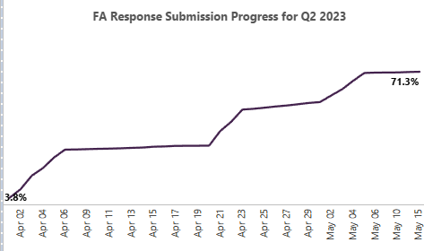 | 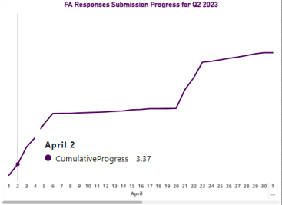
   |   
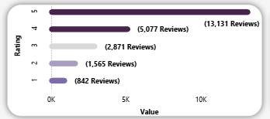 | 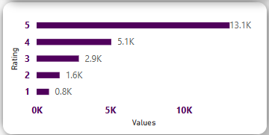
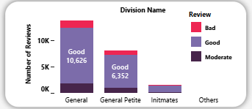 | 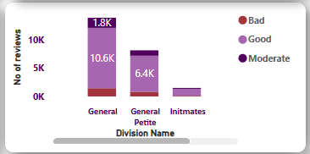
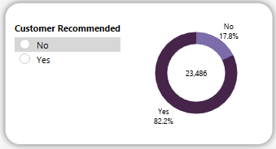 | 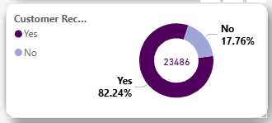
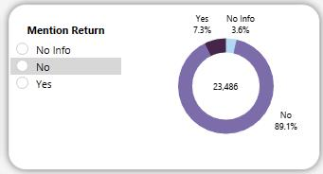 | 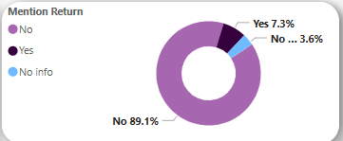
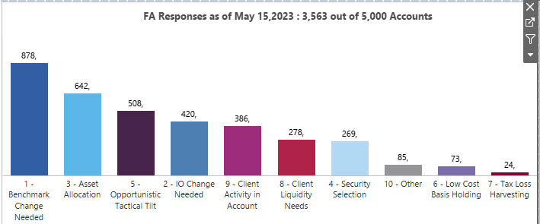

Tableau

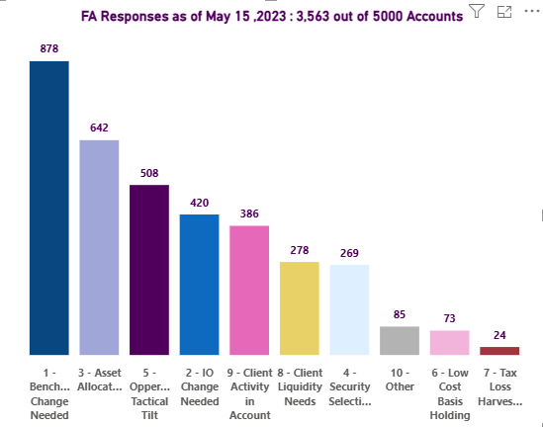

Power BI

